Public Finance Management
Action 1
Consistent with the Strategic Plan of the State Procurement Agency, increased efforts will be made to improve awareness about public procurement legislation and procedures on the part of both public agencies organising tenders and potential bidders. This will include, in particular, the creation of a training centre on public procurement at the new premises of the State Procurement Agency and/or the development, in close co-operation with the State Procurement Agency, of the permanent training module on public procurement at the Academy of the Ministry of Finance. Also, substantial progress will be made towards the introduction of a certification system.

In 2014 in order to improve knowledge and capacity of contracting authorities and suppliers about procurement procedures State Procurement Agency (hereafter SPA) established a Training Center that is an independent structural unit approved by the Charter of State Procurement Agency adopted by the Government of Georgia on 23 April, 2014 and its functions was defined by the Decree #1 of Chairman of SPA on the “Structural Unit Functions of the State Procurement Agency and its Activities”.
For implementing measures ensuring proper operation of the Training Centre the following rules and procedures were approved by the Decree of the Chairman of SPA issued on 30 September, 2014:
- The rule of appraisal and issuance of certificates by SPA Training Centre;
- Categories of trainers and rate of remuneration for one academic hour (45 minutes) considering the qualification and experience of trainers;
- Requisites for development of syllabus of training module;
- Planning and scheduling of training sessions.

Target audience to be trained at the Training Center is representatives of local self-government bodies; central government authorities and other entities governed by public law in charge with state procurement, as well as suppliers interested in participating in public tenders.
The goal of the Training Centre is (a) to provide information on the whole cycle of procurement processes starting from market research and planning to contract execution and management; (b) to advise and provide guidance to contracting authorities on how to better target businesses and SMEs especially in their tendering process; (c) to consult on remedies/reviews mechanisms based on cases handled by the Dispute Resolution Board (DRB).
Planning of Training Sessions
In October-November participants of training sessions were divided in two divisions, each of them consisting of 3 groups: each group consisted of so called employees of “problematic municipalities”, more precisely by the employees, who based on the data of SPA monitoring experienced more complications in conducting state procurement process.

Topics of the training module on state procurement:
- General review of state procurement: the essence of state procurement and scope of activity;
- Relevant normative acts; Discussion of administrative violations; State procurement regulating legislations, other acts and their connection with the state procurement;
- VAT factor in procurement process;
- General review of means of procurement;
- The whole process of state procurement;
- State procurement planning and determination of uniformity of rules;
- Uniformity determination (Common Procurement Vocabulary – CPV codes);
- Electronic state procurement system and the official website of the agency;
- Procurement planning, market survey/determination of average value, plan registration in – ePlan module, monetary thresholds, determination of the state procurement plan towards the budget, correcting procurement plan;
- Simplified procurement and contract concerning the state procurement;
- Contracts – contract conditions, shift in the contract, conflict of interest, advance payment and performance of agreement guarantee, fines;
- Procurement without awarding contract – replacing the contract with document certifying procurement (internet-shopping and so forth);
- Reporting – CMR module usage and reporting regarding the contract progress;
- Tender commission and choosing of tender apparatus, it’s functions, obligations;
- Specifics of procurement requirements;
- Compiling of tender documentation and qualification data requirements, changes, tender announcement;
- Special cases of tenders, unified, two step tenders and alternative tenders;
- Submitting tender notice, data, e-commerce;
- Compiling/granting status to the minutes/notifications , awarding contracts, submitting report on contract progress;
- Black and White Lists;
- Consolidated tender;
- Design contest – preparation of design contests application and document, announcement, discussing results and awarding contract;
- Dispute Resolution Board, it’s functions, obligations, review procedures and decisions.

Trainers of the Training Center
The training sessions are conducted by SPA employees, who also have a combined function of a trainer. Each trainer has a daily contact with public procurement policy and practice development, implementation of innovations, detection of gaps and elimination process that entails the maximum awareness and competence of trainers.

Completed training sessions (October - June, 2015)
As of May 2015, Training Center provided training sessions to the 252 employees operating at state institutions, municipalities and local self-governments from overall Georgia. In May, 2015 by the financial assistance of World Bank, State Procurement Agency conducted first training session to the 38 employees of business organizations.
Training evaluation process
In order to evaluate study programs, additional materials and trainer competence following methods are used:
- Coaching that enabled individual consultation of trainer in case of necessity
- Individual “checklists” in writing
- Presentations
- Case studies
- Group discussions
- Individual and group inquiries of trainees
Evaluation criteria of trainers’ competence are defined by the SPA Chairman decree; therefore, Training Centre administration conducts survey based on the filled out forms of trainees.

Action 2
In order to protect the operational independence of the State Audit Office (SAO), as enshrined in the Constitution of Georgia, and consistent with INTOSAI Mexico Declaration, the Parliament will amend article 35 of the Law on the State Audit Office to ensure that the Parliaments’ oversight of the SAO’s activities is limited to auditing of its financial and economic performance based on SAO’s annual financial statements.
The commission established by the decision of the Parliament of Georgia conducts financial audit (according to the items f.a, f.c and f.d) of the financial statement of the State Audit Office on an annual basis in accordance with generally accepted international auditing standards.
In addition, in the explanatory note of the draft Law of the amendment, it was mentioned that: “The Temporary Commission, established by the decision of the Parliament of Georgia, will conduct financial audit of the SAO, instead of, legal and organizational performance, control of audit quality and internal audit procedures of the SAO”.
What about the implementation of the new version of the law in practice, it is noteworthy that the financial audit of the SAO by the temporary commission of the Parliament is ongoing - the period of the audit was defined from March 1, 2015 till July 1, 2015, and then prolonged till August 1, 2015. Consequently, it will only be possible after the submission of the final audit report to identify how the amendment to the law has been reflected in practice and if it is in line with the accepted model.
Social Safety Net
Action 3
The Ministry of Labour, Health and Social Affairs will complete, with technical assistance from the World Bank, USAID and the World Health Organisation, the Health Utilisation and Expenditure Survey. The results of the Survey will provide input for the evaluation of the impact of health sector reforms on accessibility, utilisation, satisfaction and the financial protection of the population vis-à-vis health care and serve as a basis for further refining the design, operation and financial management of the Universal Health Care (UHC) programme introduced in 2013.
With the financial and technical assistance of WHO, WB and Health System Strengthening Project of USAID in September 2014, (Georgia Health utilization and Expenditure Survey III round was launched. Field works were finished in December 2014. First results of the Survey were received by the end of April, 2015. Survey was presented to the Minister of Labour, Health and Social Affairs of Georgia (MoLHSA) and the official presentation was held in the end of May.
According to the results of the survey, UHC Program became a milestone for universal coverage of population by the state funded healthcare programs. 69% of program beneficiaries did not have any insurance before. After introduction of UHC Program, out-of pocket expenditures were reduced by 23% (325 GEL in 2010 vs 248GEL in 2014). Out-of pocket expenditures were reduced in regards of self-treatment, treatment and hospital services.
Based on the results of the Survey, recommendations have been prepared, which will be encountered for enhancement of UHC Program administration as well as other directions of healthcare field.

Action 4
With a view to improving the efficiency and cost-effectiveness of the Universal Health Care and other State Health Care Programmes, the Ministry of Labour, Health and Social Affairs will establish a special Unit for Health Care Quality Improvement.

By the Resolution №760 of the Government of Georgia of December 31, 2014 amendments have been made to the Resolution №249 of the Government of Georgia of December 31, 2005 on “Approving of the Statutes of the Ministry of Labour, Health and Social Affairs of Georgia”.
According to the Governmental Resolution №760, the Article 9 of the Statutes of the Ministry of Labour, Health and Social Affairs of Georgia defines the major objectives and competencies of the Executive Department of the Ministry. Particularly, the subparagraph “თ“ of the mentioned Article includes: “Coordination of healthcare improvement activities for the enhancement of state health program efficiency”.
In addition, by the Order №01-1/n of the Minister of Labour, Health and Social Affairs of Georgia of January 6, 2015 has been approved the “Statutes of the Structural Units of the Ministry of Labour, Health and Social Affairs of Georgia”.
According to the subparagraph ც, ძ, წ, ჭ, ხ of the Article 2 of the Statutes of the Executive Department of the Ministry of Labour, Health and Social Affairs of Georgia (annex 1), the mentioned department is obliged: 1) to coordinate activities aiming assessment and analyzes of healthcare system efficiency performance; 2) to coordinate relevant activities to improve Universal Healthcare and other State Health Programmes efficiency and cost-effectiveness; 3) to receive statistical information and its analyzes for future project planning; 4) to create mechanisms and data collection, processing and sequence analysis, which are necessary for the evaluation of the effectiveness of health system performance; 5) to implement other necessary activities oriented to the provision of the quality healthcare services to the population.
Activities, undertaken in aim to improve quality of healthcare services in Georgia.
- MoHLSA has signed an agreement with Alliance for Health and Social Compact on April 6, 2014, with intention to get consultancy services including advises to the government, national and international partners and customers of Ministry on strategic cooperation development and relevant health system issues. Above mentioned agreement is guaranteeing reinforcement of regulatory role of Government in ensuring quality and safety of health services, pharmaceutical, medical devices and other medicinal products by bridging national and EU rules and regulations on medical and pharmaceutical practice.
- In the aim of improving poor maternal-infant health outcomes MoHLSA is establishing risk-appropriate care through perinatal care regionalization and referral system. Perinatal care regionalization and referral system was launched on 1st May, 2015 partially and will be fully in forced by the end of May. (corresponding normative act is the Order N01-2/N, 15 January, 2015 of the Minister of MoHLSA “On approval of Perinatal services regionalization levels and patients referral criteria” the Order N01-2/N, 15 January, 2015 of the Minister of MoHLSA. First phase of the project as a pilot will be implemented in Imereti and Racha – Lechkhumi - Kvemo Svaneti Regions.
- National program, ensuring the availability of universal/continuous healthcare services in the mountainous and cross–border municipalities, was developed and approved. (N624 Decree, of the Government of Georgia on “postgraduate medical education” of November 2014). The program provides target funding for postgraduate medical education (professional training) seekers from such municipalities in critical and of high priority medical professions. At this stage, the program provides a preparation of 24 medical education seekers, who will start working in mountainous and cross-border municipalities after the completion of the postgraduate training. Above mentioned, initiative will on the one hand contribute to access of health services of the population settled in mountainous and cross-border municipalities and on the other hand it will improve the quality of healthcare services.
- New programs, of medical specialties (“Pediatric emergency medicine”) and sub-specialties (“Computer-tomography”, MRI”, “Professional pathology” “Oral surgery and surgical dentistry”, “Angiology”, “Cardiac electrophysiology and arrhythmia management”) were prepared. This will contribute to not only the preparation in these specialties but also will improve the quality of healthcare services.
- Professional competencies in medical specialties were prepared and approved with the intention of ensuring professional regulation system organized operation and improvement of quality assurance and evaluation (“On approval of Medical specialty professional competencies” the Order N01-8/N, 30 May, 2015 of the Minister of MoHLSA).
- In the aim to eliminate hospital acquired infections and ensure infection control in yards of Health care facilities, sufficient amendments has been made and adequate requirements were determined for hospital yard cleaning and waste management in according decrees (“On approval of high risk medical activities technical ordinance” Georgian Government Decree N359, 22 November, 2010, “On approval of issue permission and determined conditions of licensing medical activities and inpatient facilities” Georgian Government Decree N385, 17 December, 2010 Decree).
- With the purpose of developing an effective system for the prevention and control of infection diseases, technical ordinance on disinfection/sterilization was prepared. (Draft Decree of the Government of Georgia “on the approval of technical ordinance for disinfection and sterilization in medical, public health and public facilities” will be soon submitted to the Government of Georgia). Technical ordinance defines general principles and basic organizational and procedural issues that are essential for a successful operation of infection control system in any healthcare facility. The document was prepared by considering the modern methods and standards for disinfection and sterilization, recommended by international organizations.
- On the purpose of developing an effective system for the prevention and control of infection diseases, mechanisms and appropriate tools (Draft amendments both in Laws of Georgia - “Law of Georgia on Enterprise Control”, “Law of Georgia on Entrepreneurs”, “Law of Georgia on State Registry” and Administrative code of Georgia. Also, draft resolution of the Government of Georgia “on approval of Technical Ordinance - for hygiene practices and safety rules for the invasive aesthetic and cosmetic procedures on the surface of human skin”, which will be approved in the near future) for state control/supervision of high risk services (information provided by public facilities about aesthetic and cosmetic procedures) were prepared. Aforementioned, ensures the fulfillment of the aesthetic and cosmetic procedures with maximum protection by minimizing the risks of infection transmission (HIV, Hepatitis B and C etc.).

Financial Sector
Action 5
Consistent with the regulation on capital adequacy adopted by the National Bank of Georgia in 2013 and Basel II rules on capital adequacy, banks in Georgia will submit to the NBG Internal Capital Adequacy Assessment Process (ICAAP) reports. Based on the ICAAP reports submitted by banks, the NBG will provide two largest banks assessments and recommendations in the context of the Supervisory Review and Evaluation Process (SREP).

All Banks submitted their Internal Capital Adequacy Assessments (ICAAPs) in September 2014 as defined by the Regulation on Capital Adequacy Requirements (Decree N100/04 of October 28, 2013 of the Governor of the NBG). In order to support banks throughout the working process, NBG distributed guidelines that revealed the minimum expectations of the supervisor for the risks which should have been covered by the ICAAP in 2013. Since banks are required to define adequate capital levels they need to hold based on their own risk profile under ICAAP, they developed their own internal models for each specific risk. The practice of developing of models and benchmarks by banks promotes better alignment with the international best practice and harmonizes our regulatory approaches with relevant Euro directives.
Currently, NBG has already completed the Supervisory Review and Evaluation Process (SREP) for the two largest banks (Bank of Georgia and TBC Bank). For the purpose of providing feedback and recommendations to the banks and encouraging them to develop better risk management techniques, the formal letters have been prepared. The letters were sent to TBC Bank and Bank of Georgia on April 29 (number of letter 627-1K) and May 11 (number of letter 641-1K) respectively. The letters included the recommendations regarding the methodologies, models and estimations used in capital calculations for certain risks. Expectations and views of the supervisors on the level of involvement from the supervisory board and management in the development and internal use of ICAAP were also provided.

Action 6
The NBG will implement the centralized risk-management framework action plan approved by the NBG Council in April 2013. As part of this plan, a Centralized Risk-Management Department will be established at the NBG. The Department will be in charge of managing operational risks, including Business Continuity Management Procedures.

The National Bank of Georgia identified risk management activities as a strategic priority and the Centralized Risk Management Department (CRMD) has been established subsequently in November, 2014. It has to be mentioned that establishment of CRMD has been preceded by NBG strong drive for organizational improvement as well as considering the recommendation of “Safeguards assessment report of IMF Financial Department, 2011”.
CRM department is accountable to governor and represents the independent body. The department ensures that centralized risk management framework is consistent to standards and approaches of the best international risk management practices and activities.
The three lines defense model has been selected to achieve the effective governance of risk management at the NBG:
As the first line of defense, operational managers own and manage risks, in other words, the NBG units are responsible for first line defense. CRMD represents the second line of defense and is responsible to implement, assess, monitor and improve CRM system bank wide. The process includes risk identification, assessment and prioritization of risks, development of an appropriate risk treatment and continuous improvement. CRM ensures that effective risk treatments are developed together with first-line risk-owners. Internal Audit (IA) is the third line of defense and ensures the effectiveness of CRM system. Appropriate reporting line to IA entitles internal auditors to challenge and effectively assess the centralized risk management practice at the NBG.
According to Article 25 of the Regulation on the National Bank of Georgia (Order N10 of 8 April, 2015 of the Board Chairman of the NBG) the functions of the Department are:
- To identify the associated risks and relevant fields related to the NBG’s activities;
- To develop the entire policy and methodology for existing and potential risks management processes;
- To analyze the processes of risk management with particular departments, including risk identification, assessment and monitoring;
- To develop the Centralized incident management system based centralized incident management tool;
- To prepare consolidated reports of incidents and risks and to introduce to governor;
- To implement and monitor the universal methodology for internal procedures of the NBG;
- To ensure that elaborated internal procedures are fully covering all NBG activities of the bank for the purpose of minimizing operational risks;
- To manage the business continuity process at NBG, to plan and provide all necessary activities: selection and updating the BC scenarios, organizing the testing, assessment and reporting);
- To coordinate with the departments of NBG in order to continuously improve the management of the systems of operational risks, business continuity and procedures;
- To provide regular reports for the governor based on the results of activities of centralized risk management department;
- To request and receive information from different structural units of the NBG in timely manner for leading and managing the activities of centralized risk management.

Trade and Competition Policy
Action 7
In order to be able to fully exploit the opportunities offered by the DCFTA, following its entering into force on 1 September, the Ministry of Finance will adopt a new internal order centralising in the Revenue Service the issuance and ex-post control of EUR1 certificates of origin.

Before the provisional application of DCFTA Georgian Legislation specifically Decree No. 420 of the Government of Georgia on the "approval of criteria for the originating country, form of the origin certificate, and rules for filling in and issuing them" regulated the issuance of EUR.1 certificate of origin in the following manner:
Article: 2. Certificate of Origin
- Certificate of Origin is a document issued by the component body of the exporting country, which unconditionally confirms the country of origin.
- If the Customs authority has reason to doubt the authenticity of the certificate of origin or the validity of date contained therein, it can address the authority issuing the certificate or any other competent body of the country issuing the certificate with a request to provide additional or correct information.
- In case of import into the customs territory of Georgia, origin of goods shall be established according to the certificate of origin issued by the competent authority of the exporting country, while in case of export – according to the certificate of origin issued by the competent authority of Georgia, unless otherwise provided by the legislation.
- In case of re-export origin of the goods shall be established according to the certificate of origin issued by the exporting country and supplied during the import into the customs territory of Georgia, while in case when certificate is not provided – according to the country of origin criteria applicable for export of goods from Georgia.
- In case of export of goods from the customs territory Georgia certificate of origin shell be issued by either the Ministry of Economy and Sustainable Development of Georgia or by the Legal Entity of Public Law Under the Ministry of Finance – the Revenue Service or the Georgian Chamber of Commerce and Industry or on the territory of Autonomous Republics of Georgia by the competent bodies designated by the Ministry of Finance of Georgia and the Ministry of Economy and Sustainable Development of Georgia. For the export of goods of grapevine origin certificate of origin shall be issued by the Legal Entity of Public Law under the Ministry of Agriculture of Georgia – the National Wine Agency, in accordance to the rules set by the Ministry of Agriculture of Georgia.
  - If the certificate of origin is issued by the Legal Entity of Public Law – the Revenue Service, it shall be possible to lodge the application and all other required documentation electronically. Certificate of Origin must be made available at any customs crossing point according to the preliminary request of the importer.
- For goods manufactured in free industrial zones the Ministry of Economy and Sustainable Development of Georgia shall issue a certificate. An appropriate certificate confirming the Georgian origin of Goods.
- There are four types of origin certificates:
  - For goods not subject to preferences (non-preferential) certificate
  - For goods subject to preferences (preferential) certificate – Form “A”
  - Preferential certificate of Origin CT-1
  - Preferential Certificate of Origin EUR.1
- Preferential Certificate of Origin – Form A is issued for specific goods exported from the customs territory of Georgia to specific countries (countries granting preferences according to the “Generalized System of Preferences”). Criteria for the country of origin and rules for the issuance and filling in of the certificate are defined in the directives of the country granting preferences.
- Non-preferential certificate of origin is issued when exporting goods to all other countries, except for cases foreseen in the International Agreements of Georgia.
- Certificate of Origin CT-1 is issued in accordance with the Decision of the Council of Heads of State of the Commonwealth of Independent States dated November 30, 2000.
- Certificate of Origin EUR.1 is issued in accordance to the “Free Trade Agreement between Georgia and the Republic of Turkey” signed November 21, 2007.

After the signing of the DCFTA between EU and Georgia on August 26, 2014 the Government of Georgia issued Decree N510 amending the Decree N420 and in doing so centralized the issuance and control of EUR.1 certificates exclusively in the Revenue Service.

As amended:
- Certificate of Origin is a document issued by the component body of the exporting country, which unconditionally confirms the country of origin.
- If the Customs authority has reason to doubt the authenticity of the certificate of origin or the validity of date contained therein, it can address the authority issuing the certificate or any other competent body of the country issuing the certificate with a request to provide additional or correct information.
- In case of import into the customs territory of Georgia, origin of goods shall be established according to the certificate of origin issued by the competent authority of the exporting country, while in case of export – according to the certificate of origin issued by the competent authority of Georgia, unless otherwise provided by the legislation.
- In case of re-export origin of the goods shall be established according to the certificate of origin issued by the exporting country and supplied during the import into the customs territory of Georgia, while in case when certificate is not provided – according to the country of origin criteria applicable for export out of Georgia.
- In case of export of goods from the customs territory Georgia certificate of origin shell be issued by:
  - the Legal Entity of Public Law Under the Ministry of Finance – the Revenue Service; or
  - the competent body of the Ministry of Economy and Sustainable Development of Georgia, except for Preferential Certificate of Origin EUR.1; or
  - the Georgian Chamber of Commerce and Industry except for Preferential Certificate of Origin EUR.1; or
  - on the territory of Autonomous Republics of Georgia by the competent bodies designated by the Ministry of Finance of Georgia and the Ministry of Economy and Sustainable Development of Georgia, except for Preferential Certificate of Origin EUR.1;
  - for the export of goods of grapevine origin certificate of origin shall be issued by the Legal Entity of Public Law under the Ministry of Agriculture of Georgia – the National Wine Agency, in accordance to the rules set by the Ministry of Agriculture of Georgia, except for Preferential Certificate of Origin EUR.1
- If the certificate of origin is issued by the Legal Entity of Public Law – the Revenue Service, it shall be possible to lodge the application and all other required documentation electronically.
- For goods manufactured in free industrial zones the Ministry of Economy and Sustainable Development of Georgia shall issue a certificate appropriate certificate confirming the Georgian origin of Goods, except for Preferential Certificate of Origin EUR.1
- There are four types of origin certificates:
  - For goods not subject to preferences (non-preferential) certificate
  - For goods subject to preferences (preferential) certificate – Form “A”
  - Preferential certificate of Origin CT-1
  - Preferential Certificate of Origin EUR.1
- Preferential Certificate of Origin – Form A is issued for specific goods exported from the customs territory of Georgia to specific countries (countries granting preferences according to the “Generalized System of Preferences”). Criteria for the country of origin and rules for the issuance and filling in of the certificate are defined in the directives of the country granting preferences.
- Non-preferential certificate of origin is issued when exporting goods to all other countries, except for cases foreseen in the International Agreements of Georgia.
- Certificate of Origin CT-1 is issued in accordance with the Decision of the Council of Heads of State of the Commonwealth of Independent States dated November 30, 2000.
- Certificate of Origin EUR.1 is issued:
  - in accordance to the Protocol I of the Association Agreement between the European Union and the European Atomic Energy Community and their Member States, of the one part, and Georgia, of the other part dated June 27, 2014.
  - in accordance to the Protocol II “Free Trade Agreement between Georgia and the Republic of Turkey” signed November 21, 2007.

As the result of the aforementioned amendment the Revenue Service has been sole responsible governmental agency and during the period starting September 1, 2014 and ending 1st quarter of the 2015 has:
- Issued 1115 Movement Certificates EUR.1

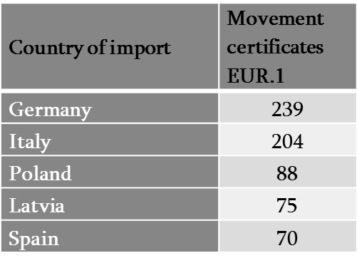
Top 5 countries of export

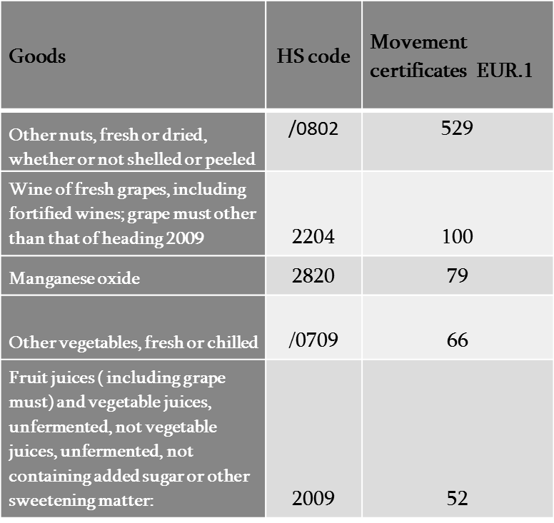
Top 5 commodities of exported

- Received 2227 Movement Certificated EUR.1 (Additional 398 Origin Declarations)

Top 5 countries imported from
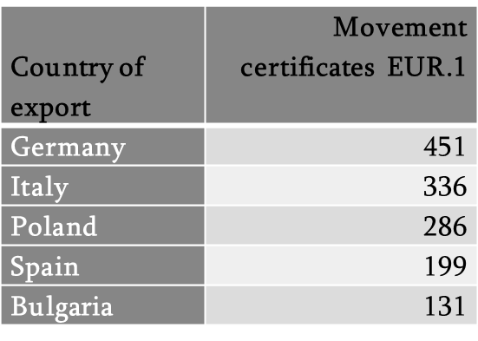

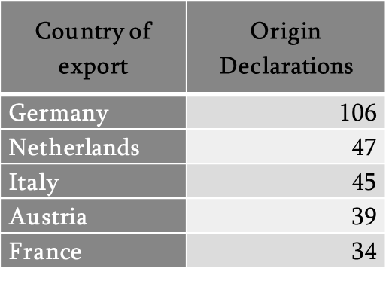

Top 5 commodities of import
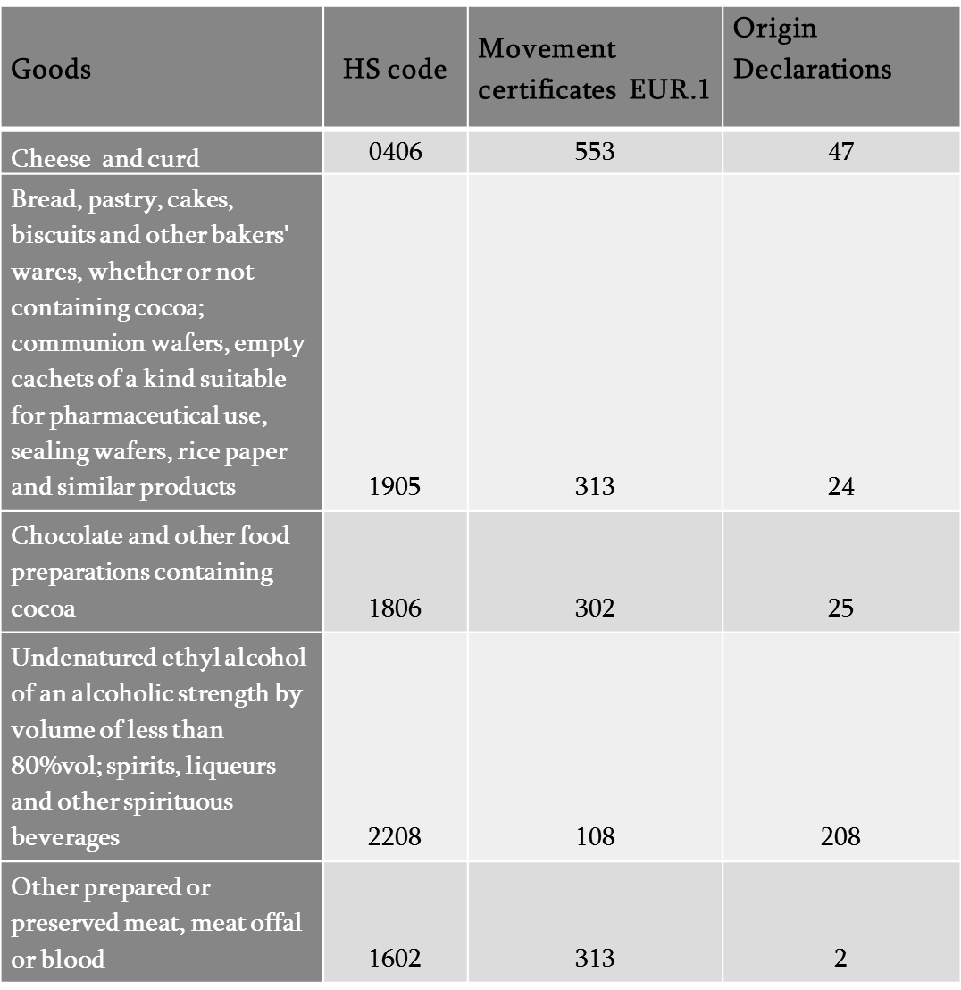
Action 8
Consistent with the commitments under the DCFTA, the Government or, where appropriate the Competition Agency, will adopt all normative secondary legislation foreseen in the Law on Competition adopted in March 2014.

Under Article 34(6) and 34(6¹) of the Georgian Law “on Competition” have been approved following by-laws:
- Two regulations of Government of Georgia:

- Regulation №526 “On Exemptions from Prohibition On Competition Restricting Agreements” (1 September, 2014)
The Objective of the By-law is:
1. The Regulationa on Exemptions from Prohibition on Competition Restricting Agreements defines exemptions from the agreements that restrict competition in the relevant markets.
2. This Regulation intends to prevent prohibition of agreements that facilitate improvement of production and/or supply, technical and economic progress, and ensure the promotion of consumer welfare.

- Regulation №529 of Government of Georgia “On Approving Small Amounts of Individual State Aid and General Procedure for Granting State Aid” (1 September, 2014)
The procedure of the above mentioned by-law is intended to:
a) Ensure non-discrimination and transparency of the procedures for granting state aid;
b) Establish a procedure for coordinating state aid with authorized bodies;
c) In case of non-compliance of state aid with the law and the provisions of this document, define the authority of the appropriate body, the Legal Entity under Public Law - the Competition Agency (hereinafter the Agency);
d) Define a small amount of individual state aid as provided for in the Law.
As provided by this procedure, the Agency is an authorized body.

- Five Orders of the Chairman of Competition Agency of Georgia:

- Order №30/09-1 - “On approval of the forms of applications and complaints, rules for their submission and procedures and deadlines related to the admissibility of the application and complaint” (30 September, 2014)
The forms of applications and complaints, rules for their submission and procedures and deadlines related to the admissibility of the application and complaint (hereinafter referred to as “Procedure”) is elaborated in accordance with the Law of Georgia on Competition (hereinafter referred to as “Law”).
The present Procedure determines the forms of application and complaints submitted by the legal entity of public law to the Competition Agency (hereinafter referred to as “Agency”) in relation to infringements of provisions foreseen in the Law, as well as the rules for their submission, procedures for admissibility and deadlines.
The procedure is applied to the Law, General Administrative Code of Georgia and other normative acts.

- Order №30/09-2 - “On Approving the Procedure for Applying the Leniency Programme and Benefiting from Exemption from Liability” (30 September, 2014)
The leniency programme is designed to fully or partially exempt an entity from the liability prescribed by law if it acknowledges involvement in the agreement referred to in Article 7(1)(a), (c) or (f) and at the same time meets the conditions laid down by the Law and this Procedure.
For the purpose of the Law and this Procedure, exemption an entity from the liability means fully or partially exemption from the penalty imposed for violating the Law.
Granted privileges, within the framework of leniency programme, might be the category one, two or three.
- The category one privilege means granting the entity up to 100% exemption from liability.
- The category two privilege means granting the entity up to 20% - 50% exemption from liability.
- The category three privilege means granting the entity a maximum of 20% exemption from liability.

- Order №30/09-3 - “On approval methodological guidelines of market analysis” (30 September, 2014)
The aim of the guidelines is assessment of methodological provision and the use of the issues regulated by the competition legislation in the following cases:
- With the purpose to evaluate competitive environment on product market;
- In the process of assessing the structure of the relevant market, the degree of concentration, share of economic agent in a dominant position, determination of group dominance and market power;
- In the process of discussing cases related to infringement of competition legislation;
- In the process of discussing concentration cases under notification or the concentration cases under violation of the law;
- In the process of monitoring conducted by the LEPL Competition Agency (hereinafter referred as the “agency”) and directed to competitive policy, conducting study and analysis of social-economic outcomes on product market;
- In the process of discussing the protection of the competition or received or receivable regulations in the commodity market and also received or receivable decisions of the economic agents' assistance (subsidies) by the administrative organs or judicial acts and/or in other cases established by the Law, which require analysis of competitive environment in goods/services markets, and the assessment of the situation or action of economic agents.

- Order №30/09-4 - “On approval the procedure on submission and consideration of notification on concentration” (30 September, 2014)
The purpose of the present Rule is:
- Assessment of the concentration in the relevant goods market, determination of the marginal number of the concentration subject to notification and determination of the notification and review procedures.
- The prohibition of the concentration of economic agents, which restricts effective competition in the relevant market;
- Determination of submission of forms;
- Ensuring the transparency and objectivity of the process of consideration of notification about concentration.
The present Rule sets up:
- The defining of the marginal number of criteria and rules of calculation of preliminary obligatory notification (hereinafter referred to as - notification) of concentration to the LEPL Competition Agency (hereinafter referred to as - agency);
- Procedures and rules of submission for consideration of notification.
Implementation of concentration, which is subject to notification, shall be allowed only on the positive decision of the agency on it is in conformity with the normal competitive environment.
Negative decision issued by the agency იn accordance with legislation shall be the basis for the refusal on the registration of an economic agent.

- Order №30/09-5 - “On approval of the rule and procedure of investigation“ (30 September, 2014)
The present Rule determines the rule and procedure for carrying out investigation by the legal entity of public law Competition Agency (hereinafter referred to as “Agency”) in relation to infringements of provisions foreseen in the Law, as well as the rights and obligations of the parties involved in course of investigation.
The Agency shall be authorized to start investigation on the basis of application or complaint or by its own initiative.
The basis for commencement of investigation shall be reasonable assumption that relevant articles of the Law have been infringed.

